Harewood Cricket Club

Established

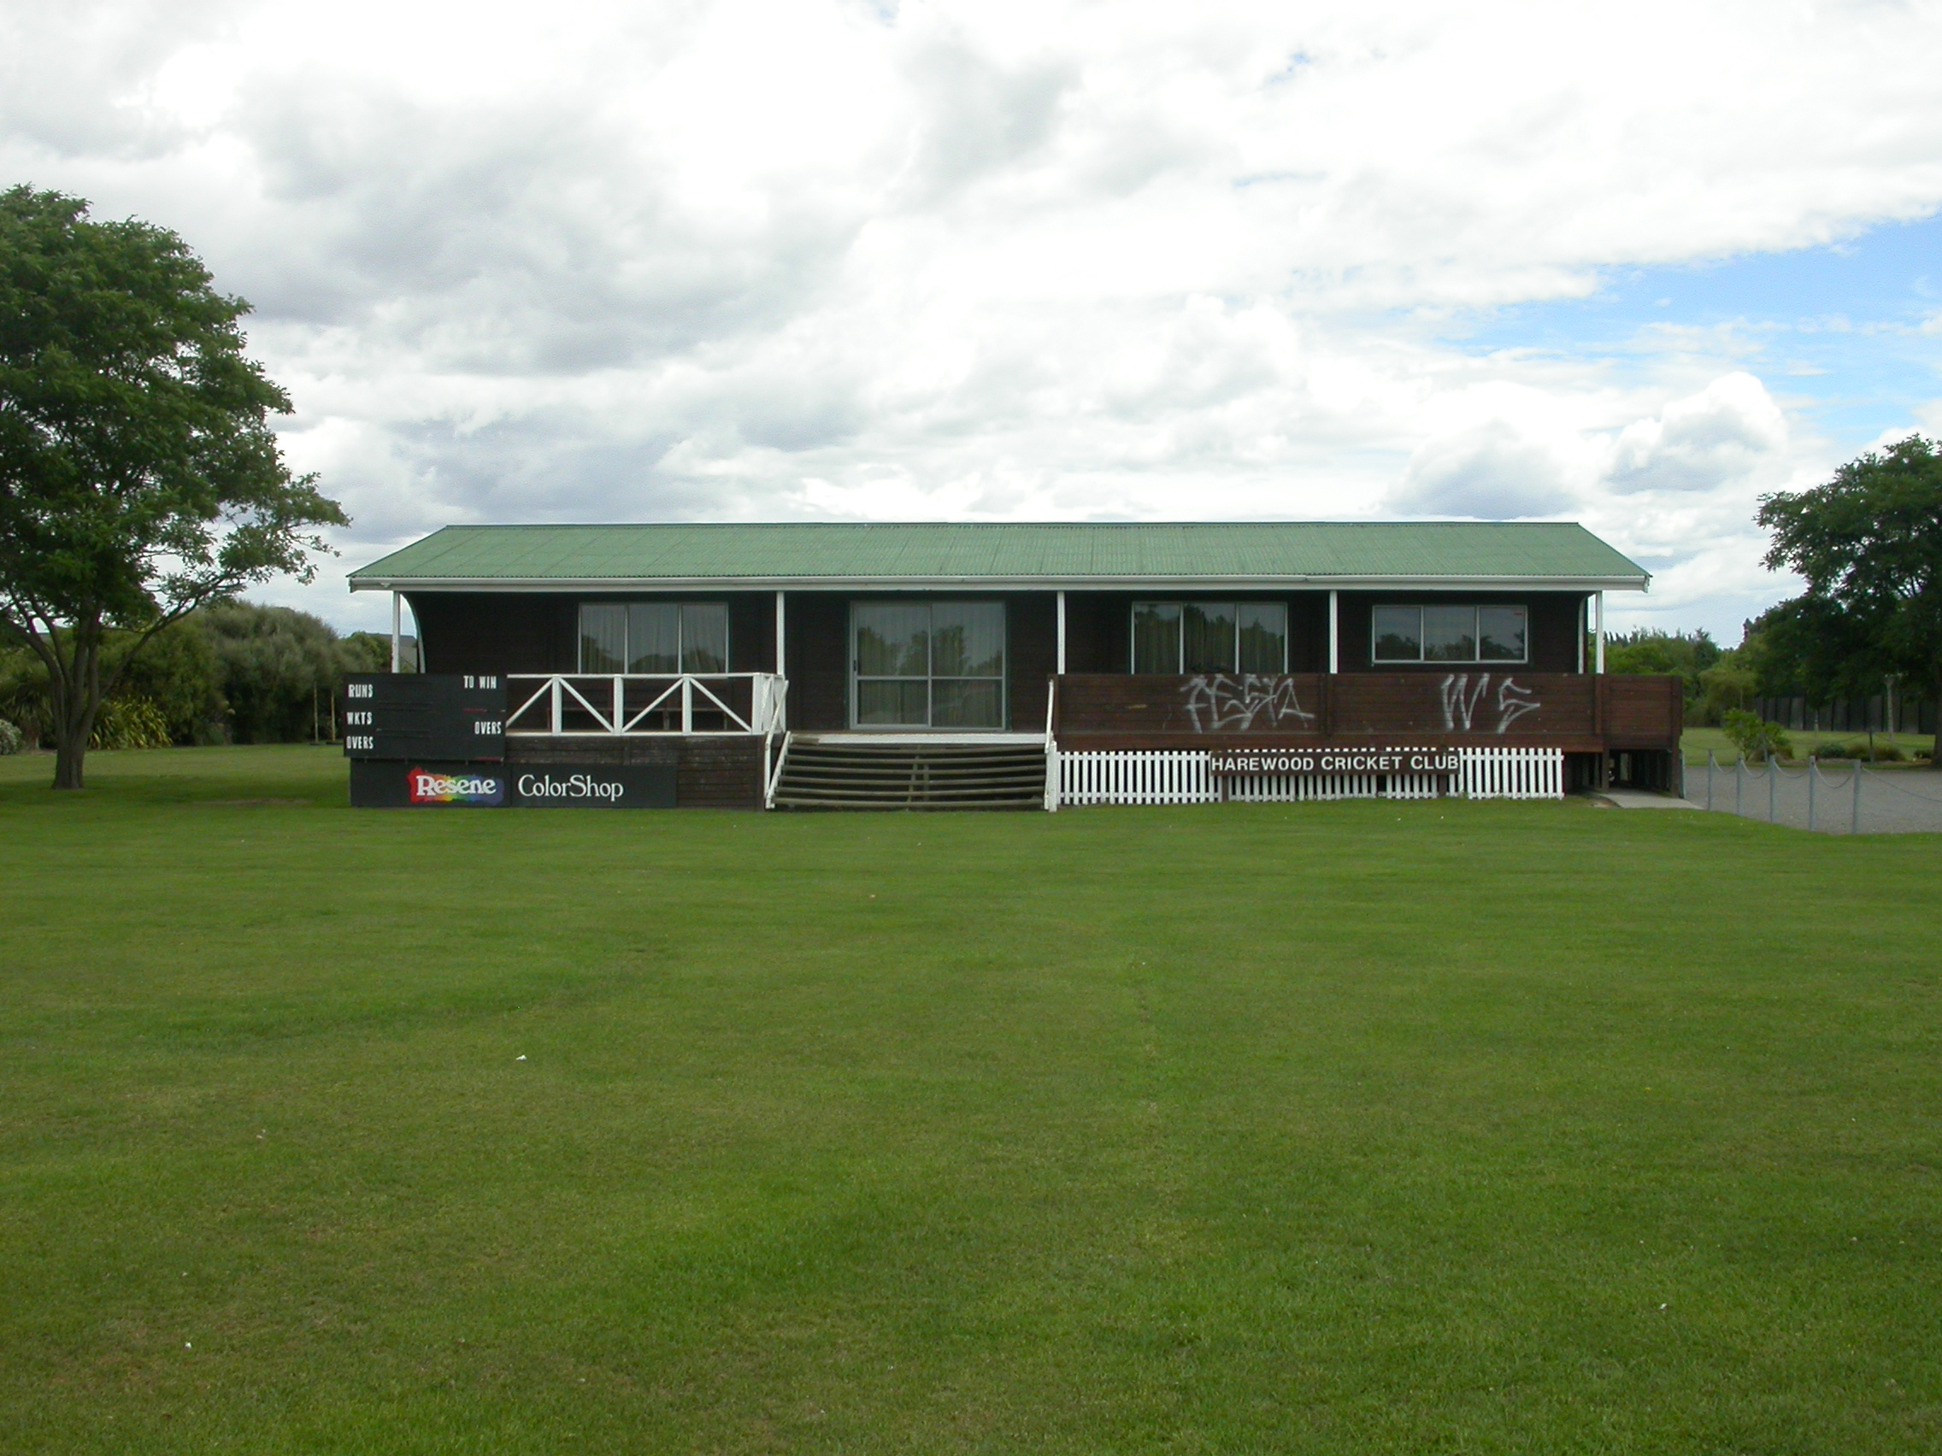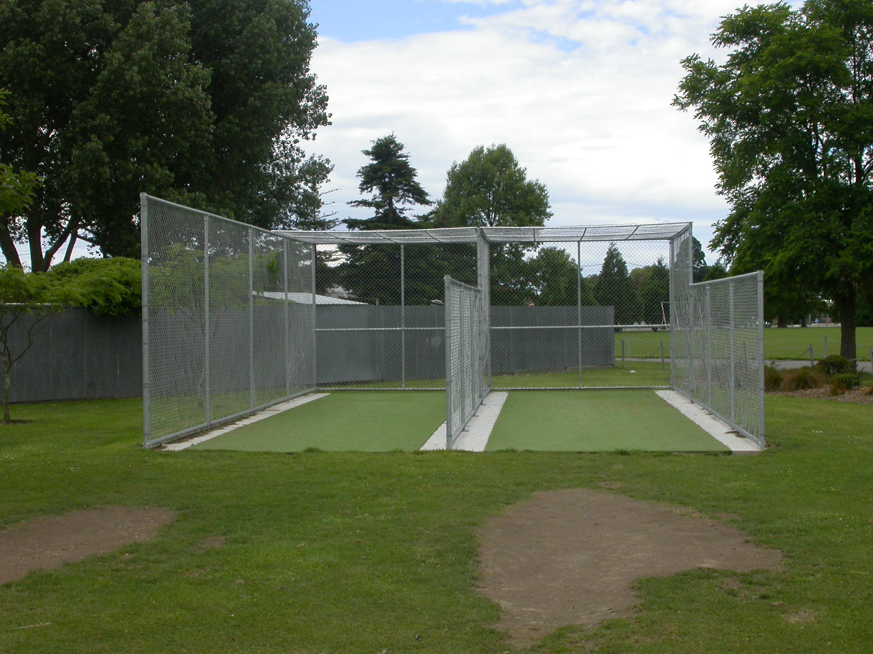

Home Ground Redwood Park
Match pitches 2 grass match pitches
Practice pitches 2 artificial pitches
Secondary ground St James Park 1 grass pitch
Sheldon Park 1 grass pitch
Entries 2001-02 5 men teams 2 women teams 2 junior teams
2002-03 7 men teams 2 women teams 11 junior teams
2003-04 6 men teams 1 women teams 4 junior teams
2004-05 4 men teams 1 women teams 4 junior teams
2005/06 4 men’s teams 4 junior teams
Grade wins last 5 years 2002-03 Senior B

